**PEMROGRAMAN MOBILE**

**APLIKASI LAUNDRY**

Dosen pengampu: Nurfiah. S.ST, M.Kom



**RAFANO ALESANDER (2211533016)**

**DEPARTEMEN INFORMATIKA**

**FAKULTAS TEKNOLOGI INFORMASI**

**UNIVERSITAS ANDALAS**

**2024**

**CONNECT TO JSON**

1. **Model Pelanggan**

**package** com.example.connecttojson;

**public** **class** **ModelPelanggan** {

String id, nama, email, hp;

**public** String **getId**(){ **return** id; }

**public** **void** **setId**(String id){ this.id = id; }

**public** String **getNama**() { **return** nama ;}

**public** **void** **setNama**(String nama) { this.nama = nama; }

**public** String **getEmail**() { **return** email ;}

**public** **void** **setEmail**(String email) { this.email = email; }

**public** String **getHp**() { **return** hp ;}

**public** **void** **setHp**(String hp) { this.hp = hp; }

}

1. **Adapter Pelanggan**

**package** com.example.connecttojson;

**import** android.content.Context;

**import** android.view.LayoutInflater;

**import** android.view.View;

**import** android.view.ViewGroup;

**import** android.widget.TextView;

**import** androidx.recyclerview.widget.RecyclerView;

**import** java.util.List;

**public** **class** **AdapterPelanggan** **extends**

**RecyclerView**.Adapter<AdapterPelanggan.ViewHolder> {

**private** **static** **final** String TAG =

AdapterPelanggan.class.getSimpleName();

**private** Context context;

**private** List<ModelPelanggan> list;

**private** View.OnClickListener onItemClicked;

**public** **void** **setOnItemClickListener**(View.OnClickListener

itemClickListener) {

onItemClicked = itemClickListener;

}

**public** **AdapterPelanggan**(Context context, List<ModelPelanggan> list) {

this.context = context;

this.list = list;

}

@Override

**public** ViewHolder **onCreateViewHolder**(ViewGroup parent, int viewType) {

View view =

LayoutInflater.from(parent.getContext()).inflate(R.layout.item_pelanggan,

parent, false);

**return** **new** **ViewHolder**(view);

}

@Override

**public** **void** **onBindViewHolder**(ViewHolder holder, int position) {

ModelPelanggan item = list.get(position);

holder.tvNama.setText(item.getNama());

holder.tvHp.setText(item.getHp());

}

@Override

**public** int **getItemCount**() {

**return** list.size();

}

**public** **void** **clear**() {

int size = this.list.size();

this.list.clear();

notifyItemRangeRemoved(0, size);

}

**public** **class** **ViewHolder** **extends** **RecyclerView**.ViewHolder {

TextView tvNama, tvHp;

**public** **ViewHolder**(View itemView) {

super(itemView);

tvNama = (TextView) itemView.findViewById(R.id.tvItemPelNama);

tvHp = (TextView) itemView.findViewById(R.id.tvItemPelHp);

itemView.setTag(this);

itemView.setOnClickListener(onItemClicked);

}

}

}

* Metode onCreateViewHolder dipanggil ketika RecyclerView membutuhkan ViewHolder baru. ViewHolder dibuat dengan cara meng-inflate layout item, lalu mengembalikannya
* Metode onBindViewHolder digunakan untuk menghubungkan data dari objek pada posisi tertentu ke tampilan yang sesuai (TextView) dalam item RecyclerView.
* Metode getItemCount mengembalikan jumlah item dalam daftar pelanggan (list).
* Metode clear digunakan untuk menghapus semua item dari daftar pelanggan, dan kemudian memberitahu adapter bahwa data telah berubah sehingga item yang ditampilkan akan diperbarui atau dihapus dari RecyclerView.
* ViewHolder Class adalah kelas yang memegang referensi terhadap elemen tampilan di dalam item RecyclerView.

1. **MainActivity**

**package** com.example.connecttojson;

**import** android.app.ProgressDialog;

**import** android.content.Intent;

**import** android.os.Bundle;

**import** android.util.Log;

**import** android.view.View;

**import** android.view.animation.AlphaAnimation;

**import** android.widget.Button;

**import** android.widget.Toast;

**import** androidx.activity.EdgeToEdge;

**import** androidx.appcompat.app.AppCompatActivity;

**import** androidx.core.graphics.Insets;

**import** androidx.core.view.ViewCompat;

**import** androidx.core.view.WindowInsetsCompat;

**import** androidx.recyclerview.widget.LinearLayoutManager;

**import** androidx.recyclerview.widget.RecyclerView;

**import** com.android.volley.Request;

**import** com.android.volley.RequestQueue;

**import** com.android.volley.Response;

**import** com.android.volley.VolleyError;

**import** com.android.volley.toolbox.JsonObjectRequest;

**import** com.android.volley.toolbox.Volley;

**import** org.json.JSONArray;

**import** org.json.JSONException;

**import** org.json.JSONObject;

**import** java.util.ArrayList;

**public** **class** **MainActivity** **extends** **AppCompatActivity** {

//buat variabel volly untuk mengirim request ke json

RequestQueue requestQueue;

String base_url = "http://10.44.9.113/belajar_api/costumer.php";

RecyclerView rvPelanggan;

AdapterPelanggan adapterPelanggan;

ArrayList<ModelPelanggan> list;

ProgressDialog progressDialog;

AlphaAnimation btnAnimasi = **new** **AlphaAnimation**(1F, 0.5F);

Button btnAdd;

@Override

**protected** **void** **onCreate**(Bundle savedInstanceState) {

super.onCreate(savedInstanceState);

EdgeToEdge.enable(this);

setContentView(R.layout.activity_main);

ViewCompat.setOnApplyWindowInsetsListener(findViewById(R.id.main), (v, insets) -> {

Insets systemBars = insets.getInsets(WindowInsetsCompat.Type.systemBars());

v.setPadding(systemBars.left, systemBars.top, systemBars.right, systemBars.bottom);

**return** insets;

});

setView();

requestQueue = Volley.newRequestQueue(this);

getdata();

btnAdd.setOnClickListener(**new** **View**.OnClickListener() {

@Override

**public** **void** **onClick**(View view) {

Intent a = **new** **Intent**(MainActivity.this, AddActivity.class);

a.putExtra("param", "add");

startActivity(a);

}

});

}

**private** **void** **setView**() {

progressDialog = **new** **ProgressDialog**(this);

rvPelanggan = findViewById(R.id.rvLayanan);

btnAdd = (Button) findViewById(R.id.btnAdd);

list = **new** **ArrayList**<>();

LinearLayoutManager llm = **new** **LinearLayoutManager**(this);

llm.setOrientation(LinearLayoutManager.VERTICAL);

rvPelanggan.setLayoutManager(llm);

rvPelanggan.setHasFixedSize(true);

}

**private** **void** **showMsg**() {

progressDialog.setTitle("Informasi");

progressDialog.setMessage("Loading Data..");

progressDialog.setCancelable(false);

progressDialog.show();

}

**private** **void** **getdata**() {

JsonObjectRequest jsonObjectRequest = **new** **JsonObjectRequest**(Request.Method.GET,

base_url, null, **new** **Response**.Listener<JSONObject>() {

@Override

**public** **void** **onResponse**(JSONObject jsonObject) {

**try** {

String status = jsonObject.getString("status");

String messege = jsonObject.getString("message");

**if** (status.equalsIgnoreCase("true")){

// ambil json array dari objek data

JSONArray jsonArray = jsonObject.getJSONArray("data");

**for** (int a=0; a<jsonArray.length(); a++){

JSONObject jsonObject1 = jsonArray.getJSONObject(a);

ModelPelanggan mp = **new** **ModelPelanggan**();

mp.setId(jsonObject1.getString("id"));

mp.setNama(jsonObject1.getString("nama"));

mp.setEmail(jsonObject1.getString("alamat"));

mp.setHp(jsonObject1.getString("hp"));

list.add(mp);

}

adapterPelanggan = **new** **AdapterPelanggan**(MainActivity.this, list);

adapterPelanggan.notifyDataSetChanged();

rvPelanggan.setAdapter(adapterPelanggan);

// adapterLayanan.setOnItemClickListener(onClickListener);

Toast.makeText(MainActivity.this, ""+jsonArray.toString(), Toast.LENGTH_SHORT).show();

}**else** {

Toast.makeText(MainActivity.this, ""+messege, Toast.LENGTH_SHORT).show();

}

} **catch** (JSONException e) {

**throw** **new** **RuntimeException**(e);

}

Log.i("data_costumer", jsonObject.toString());

}

}, **new** **Response**.ErrorListener() {

@Override

**public** **void** **onErrorResponse**(VolleyError error) {

}

});

requestQueue.add(jsonObjectRequest);

}

}

* **XML**

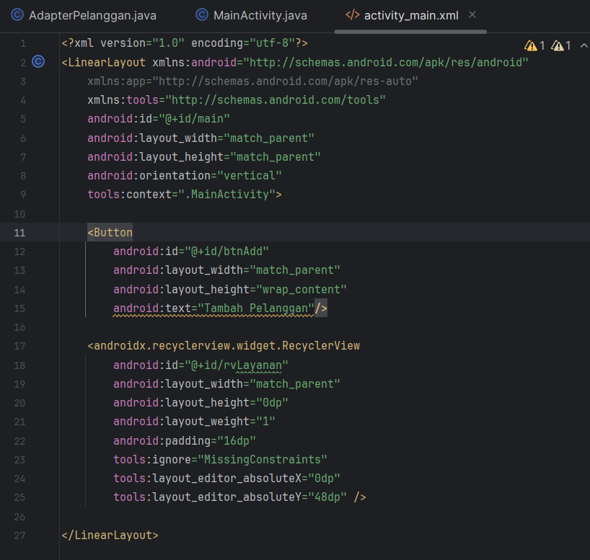

* **Tampilan**

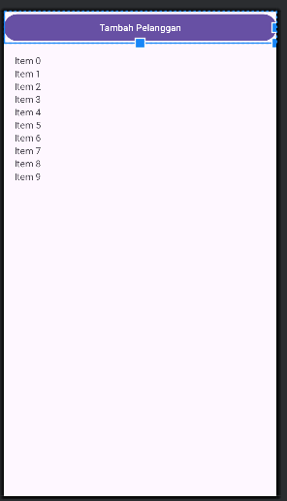

1. **Manifest**

<?xml version="1.0" encoding="utf-8"?>

<manifest xmlns:android="http://schemas.android.com/apk/res/android"

xmlns:tools="http://schemas.android.com/tools">

<uses-permission android:name="android.permission.INTERNET" />

<application

android:allowBackup="true"

android:dataExtractionRules="@xml/data_extraction_rules"

android:fullBackupContent="@xml/backup_rules"

android:icon="@mipmap/ic_launcher"

android:label="@string/app_name"

android:roundIcon="@mipmap/ic_launcher_round"

android:supportsRtl="true"

android:theme="@style/Theme.ConnectToJson"

tools:targetApi="31">

<activity

android:name=".AddActivity"

android:exported="false" />

<activity

android:name=".MainActivity"

android:exported="true">

<intent-filter>

<action android:name="android.intent.action.MAIN" />

<category android:name="android.intent.category.LAUNCHER" />

</intent-filter>

</activity>

</application>

</manifest>

1. **Data Postman**

